Java Programming
Section 3.3 practice
- B. Rishitha
- 192324130

Genericstack:

import java.util.ArrayList;

// GenericStackException class
class GenericStackException extends RuntimeException {
public GenericStackException(String message) {
super(message);
}
}

// GenericStack class
class GenericStack<T> {
private ArrayList<T> items;
private int top;

public GenericStack() {
items = new ArrayList<>();
top = 0;
}

private boolean isEmpty() {
return top == 0;
}

public void push(T item) {
items.add(item);
top++;
}

public T pop() {
if (isEmpty()) {
throw new GenericStackException("Underflow Error");
}
return items.remove(--top);
}
}

// StackDriver class
public class StackDriver {
public static void main(String[] args) {
GenericStack<Integer> stack = new GenericStack<>();
stack.push(1);
stack.push(2);
stack.push(3);
stack.push(4);

try {
for (int i = 0; i < 5; i++) {
System.out.println("Popped: " + stack.pop());
}
} catch (GenericStackException e) {
System.out.println(e.getMessage());
}
}
}

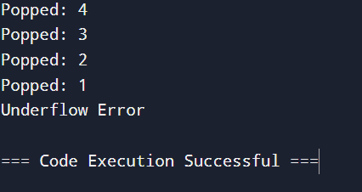

Storing Courses and Their Codes Using a Map

import java.util.HashMap;
import java.util.Map;

public class CourseCollection {
public static void main(String[] args) {
// 5a: Using a HashMap to store courses and their codes
Map<String, String> courses = new HashMap<>();
courses.put("CIT", "Computing and Information Technology");
courses.put("CHI", "Childcare and Early Education");
courses.put("MVS", "Motor Vehicle Systems");
courses.put("BTH", "Beauty Therapy");
courses.put("GDE", "Graphic Design");

// Printing out the list of courses
System.out.println("Course List:");
for (Map.Entry<String, String> course : courses.entrySet()) {
System.out.println(course.getKey() + ": " + course.getValue());
}

// 5b: Using the get method to retrieve the course name for a specific code
String courseCode = "CIT";
String courseName = courses.get(courseCode);
System.out.println("\nCourse name for code " + courseCode + ": " + courseName);
}
}

